2010 Paper, Model Answers

1a. An alloy is the combination of two or more metals, which has different properties to the metals by themselves. Steel is made by combining iron and a small amount of carbon.

*Note:* Many exam papers start with “What is the definition of…” type questions to settle you into the exam gently. They’re commonly to do with testing your resistant materials (wood, man-made boards, plastics, metals, etc) knowledge. Make sure you’ve been through your notes and know examples of each.

1b. A hardwood is one which comes from a deciduous tree (one which sheds its leaves). Examples are balsa and oak.

2a. An analogue input is one which can have a range of values, as opposed to a digital input which can only be in one of two states (on and off).

2b. A digital display is one which shows output in fixed increments (e.g. a bar display, or a 7 segment display.

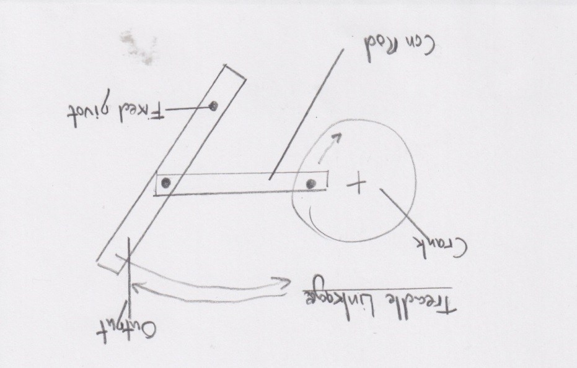

3. In the system shown to the right, a DC motor provides the electrical input, driving the crank. As it rotates, the con-rod reciprocates, causing the output to oscillate about the fixed pivot point.

4a.

The LDR’s resistance drops in response to light.

As this happens, when the potential divider setup (from the LDR and variable resistor) causes increasing amounts of voltage to reach the base.

When the light level is sufficiently high, 0.7V will reach the base of the first NPN transistor (these are arranged as a Darlington pair).

This causes current to be allowed to flow from the collector to the emitter on TR1 and TR2.

The coil in relay (RL1) energises, causing the switch to change state.

Having its power source taken away causes the motor to stop spinning.

*Note:* In this question, I wrote each step on a new line, to help the examiner see that I could identify the different things happening in the circuit. I included little extra details (like naming the Darlington pair) to further demonstrate my understanding. Keep a close watch on the details to hit top marks - notice that the relay is set up to stop the motor when energised, rather than start it!

4b i. The base resistor limits the maximum amount of current that can flow into the base, to protect the transistors.

*Note:* This is also a common thing to do when putting transistors as outputs on PIC chips.

4b ii. The Variable resistor allows the system to be calibrated so that different amounts of light will cause the motor to cut out.

*Note:* Using a variable resistor (or potentiometer) in a circuit like this is a great way of adding the ability to “tune” a circuit. In a batch of 1000 LDRs, for example, no two will be exactly the same in their response to light.

5a i. Tensile strength is the amount of force required to pull something (e.g. a rope or bolt) to the point that it breaks.

*Note:* Do you also know what compressive strength and [fusibility](http://en.wikipedia.org/wiki/Fusibility) are, or how to test for [toughness](http://en.wikipedia.org/wiki/Toughness)?

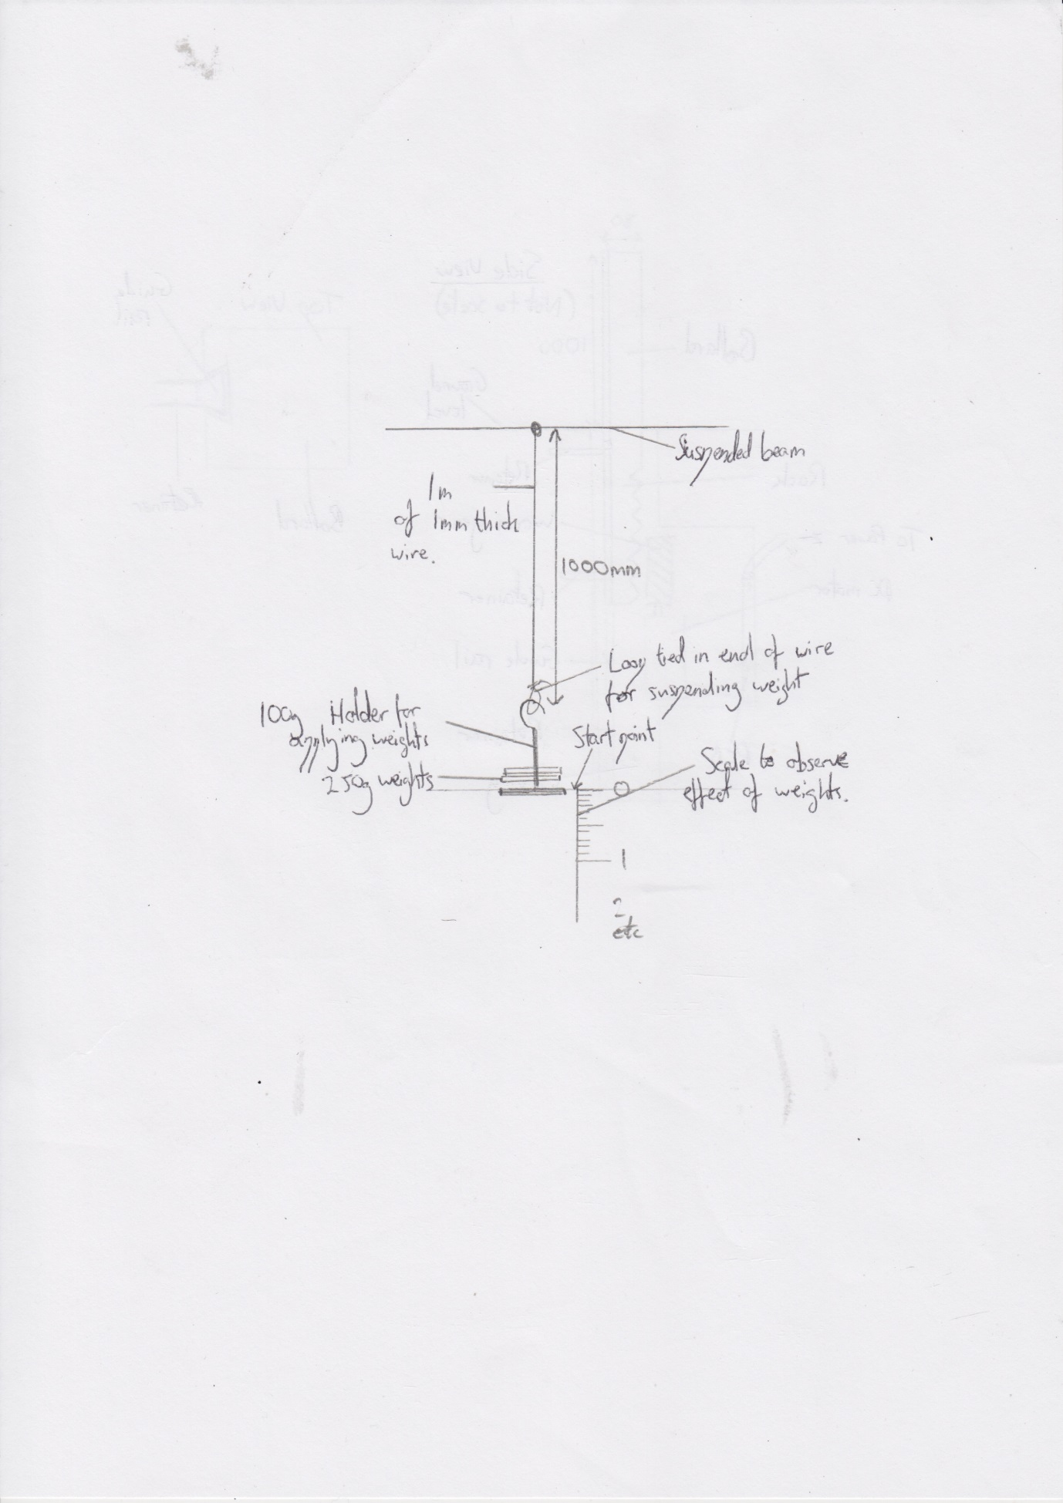

5a ii. In order to ensure the test is fair, I’d test a 1000mm section of 1mm wire from each type of metal I wanted to compare.

To apply a load, I’d use a weight holder with a hook on the end (as found in labs) which had a known starting weight, and suspend it from a loop tied in the end of each sample. I could then add load incrementally.

As each weight is added, I could use a ruler (or a Vernier caliper to increase the accuracy of my measurement) to record how much the sample stretched (also known as ductility).

I would continue to add weight until the sample broke, which is its Ultimate Tensile Strength.

I could analyse the data by plotting a graph showing the ultimate tensile strength of each sample side by side, so I could rank them.

*Note:* When concocting my test for this, I ensured that I addressed each of the bullet points raised in the question, so as to ensure I could achieve all the marks available.

5b i. Compressive strength is the ability of a material to resist a compressing (crushing) force on a material until it is permanently deformed.

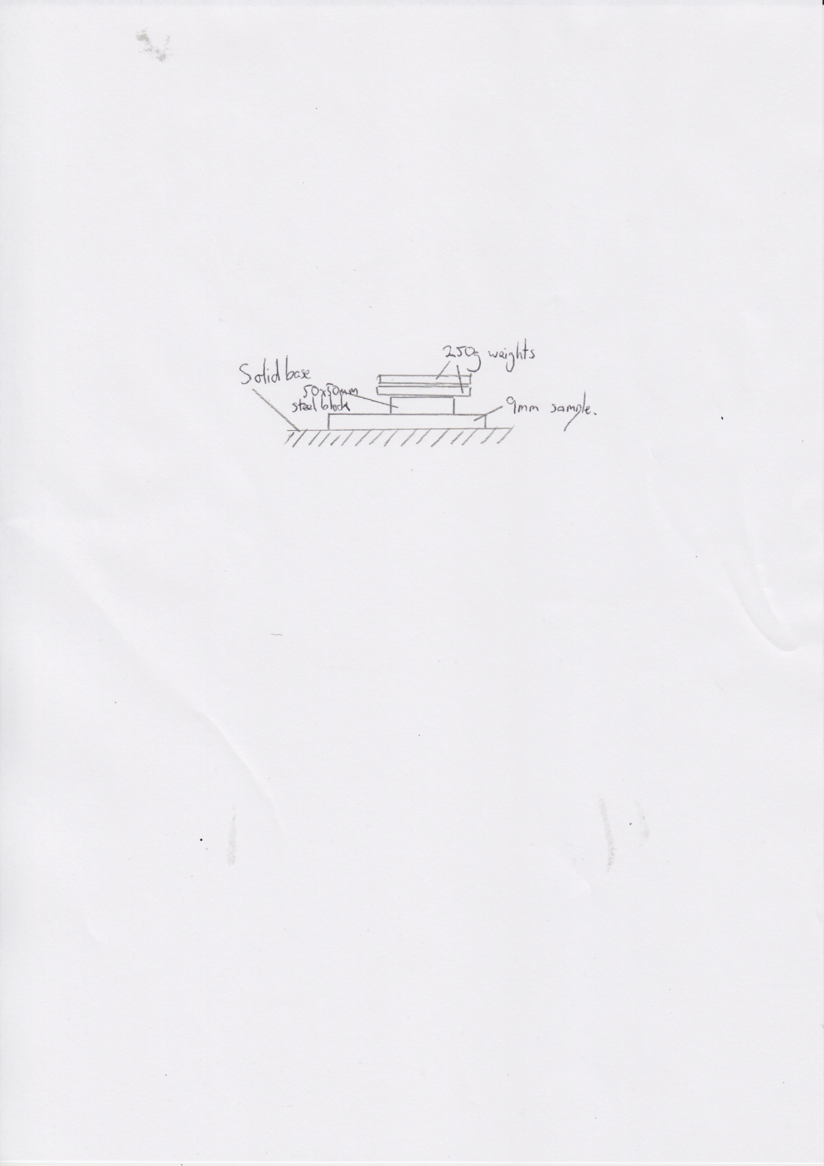5b ii. Samples of all the woods would be obtained, measuring 150x150x9mm, to ensure the test is fair.

To ensure that force is exerted evenly, a steel block of known weight with a footprint of 50x50mm is placed in the centre of the sample and its location marked with a pencil to ensure it is placed in the same place after each application of force.

Weights are added incrementally (500g at a time), and after each has been applied for 10s, the weights are removed, and any deformation in the wood is measured with a Vernier caliper and recorded.

Once gathered, line graphs can be produced of each wood, so that the characteristics of each type of wood in response to compressive forces can be compared.

*Note:* When designing a test (like this one), I did a quick thought experiment in which I imagined I’d got a block of MDF, and tried to guess how much weight I’d need to pile on to start to deform the material, and used that as the basis for how much weight I’d add at each stage. As long as your answer is reasonable, you’ll score the marks in questions like these, but you must state dimensions if you’re asked to.

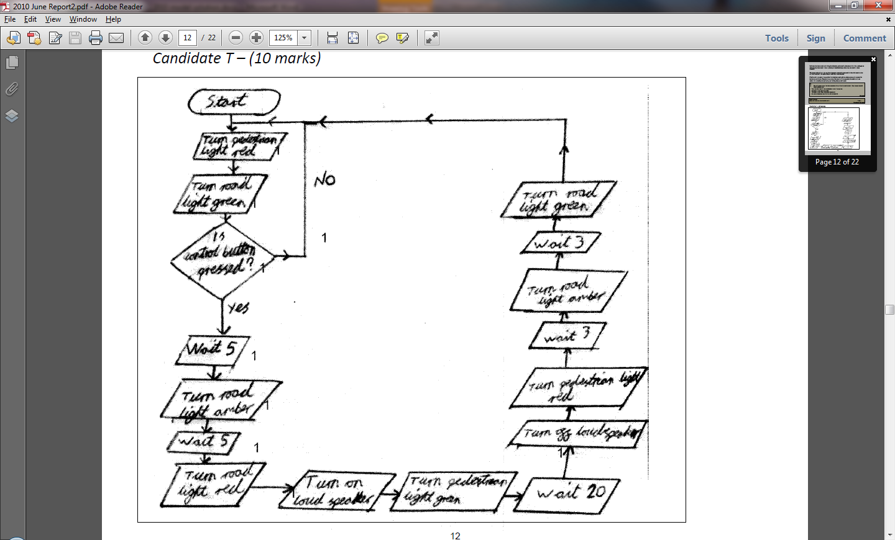

6a. *Note:* I took an exemplar answer from the exam board here. Note that they used the wrong shape for their “wait” boxes (should have been rectangular). The exam board seem to like candidates to use 0 and 1 rather than Yes and No coming off of decisions.

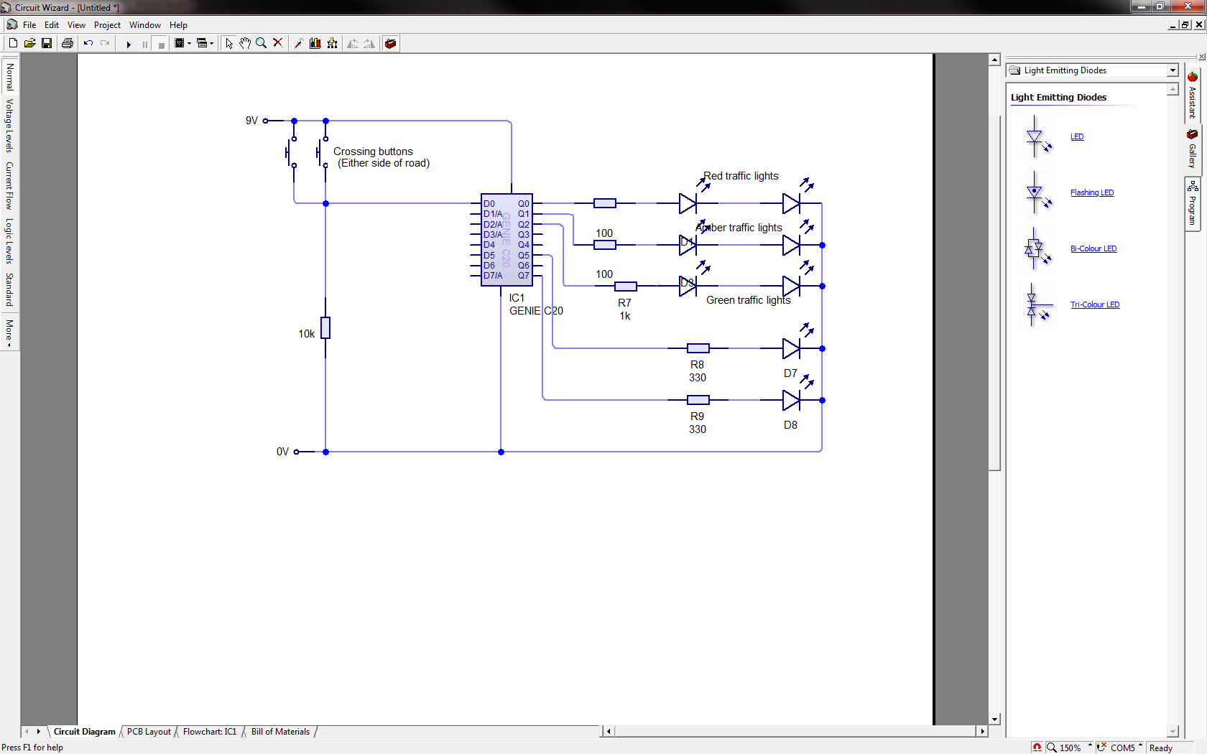

6b. In this system, I’d use the program in the previous part of the question as the program for the PIC chip. I’ve put all the system inputs on the left-hand side of the PIC, and outputs over to the right.

The bottom two LEDs are the ones that go on the lights that indicate to the pedestrian whether to stop or go.

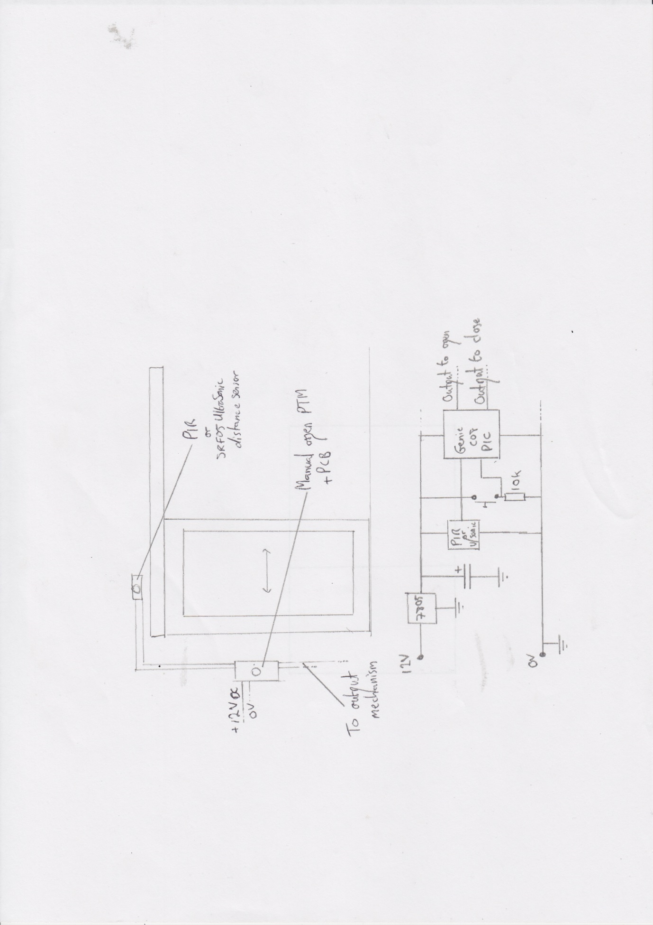7a. Either a PIR sensor (Passive Infra Red – a digital input, as used as motion detectors in burglar alarms) or an analogue SRF05 ultrasonic distance sensor would be mounted above the door, giving it an unobstructed view of people approaching the door.

By having the PCB (and a manual override switch) nearby, convenient maintenance is possible, and wiring can be hidden inside the wall, or neatly tacked with cable clips hammered onto the wall.

Using a PIC will give 5V outputs that can go on to activate the mechanism to open and close the door when appropriate.

*Note:* These questions carry huge numbers of marks, so leave nothing to chance. Draft out circuit diagrams and sketches before putting them on the paper, and always consider what things will be made from and how they’ll be held down. I used the Earth symbol (the horizontal lines forming a triangle) where I wanted a connection to my 0V rail. You don’t have to do this – I only did it because when I started sketching the diagram I didn’t want to end up with wire everywhere. Note that I was clear about providing an output from the PIC, which is worth a mark, and sets me up nicely for the next parts of this question.

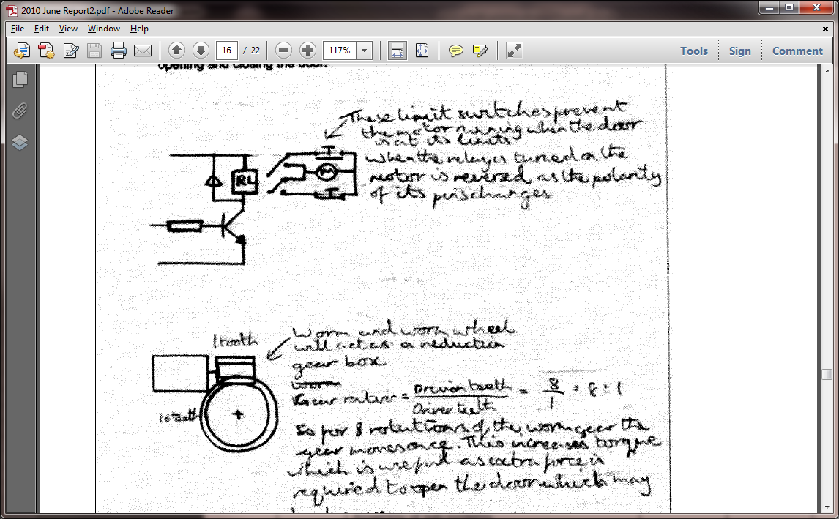

7b.

*Note:* Using PTBs like that is a great way of making a DPDT switch cut out when the door is fully opened or closed (known as “*when the motor is at the end of travel*”).

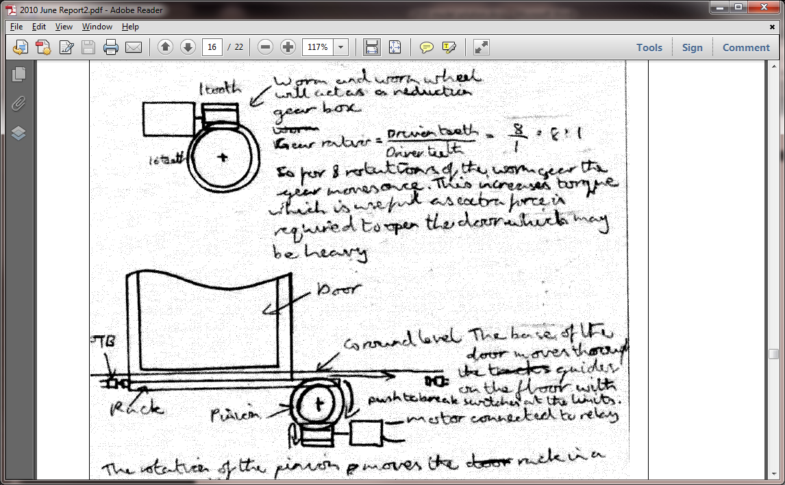

*Note:* Again, I’ve borrowed from the “official” example here. I like that they’ve suggested a gear ratio, and the combination of a little circuit snippet (don’t forget those flyback diodes) and a close-up of the mechanism is a great way of showing your knowledge.

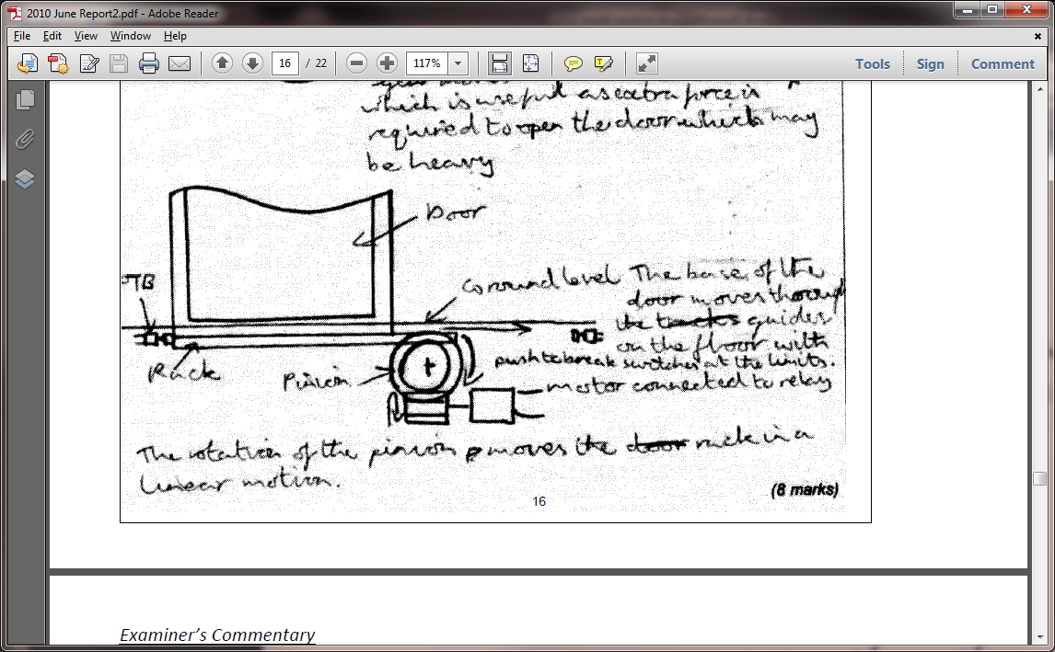

*Note:* (this is still 7b) After the close-ups so we can see the detail, the long shot allows the examiner to see exactly what you’re trying to accomplish and a clear indication of how you’ll achieve it.

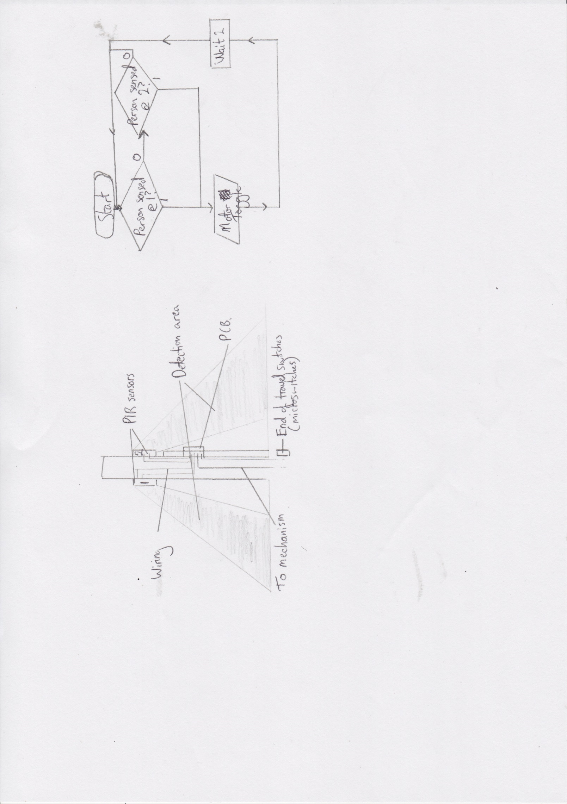

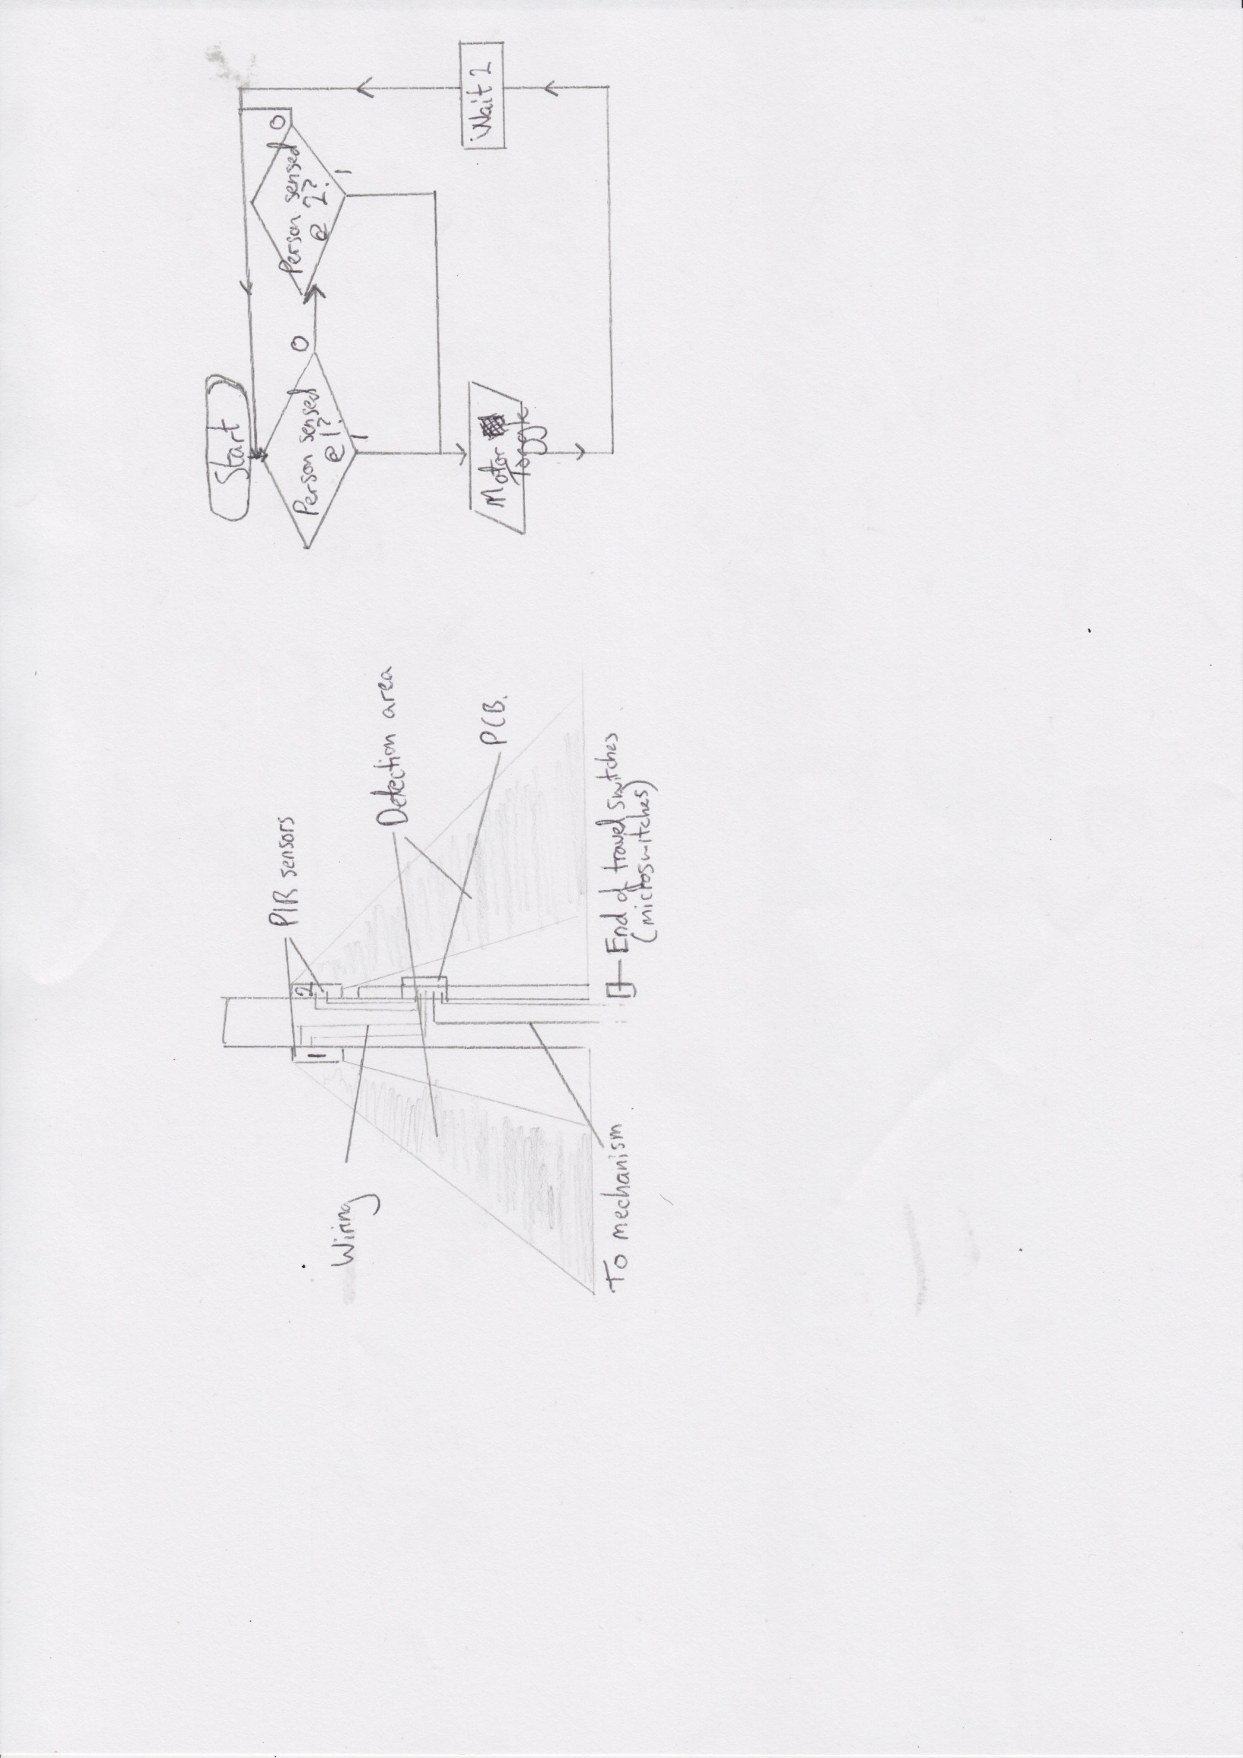7c. By adding a second PIR to the other side of the door, and experimenting by covering parts of the lens, I can control the area that the sensor covers. The PIC program will wait until someone is detected, then toggle the motor (to drive the door open). Because PTB switches are used after the relay, the door will automatically stop when fully open.

The program then waits 2 seconds to ensure the person doesn’t trigger the first PIR they triggered, then waits for another PIR to be triggered. Once this happens, the motor is reversed until the door is fully closed, at which point the PTB switch will stop the motor.

*Note:* In my answer to this, I made sure that I included a flowchart as proof that my idea would work. In reality, this would not be ideal as if two people were approaching from different directions, the door could close on one of them. A better solution might have been to have had IR detectors on one side of the door frame and IR LEDs on the other (as opposed to lasers). I could then have had the program so that the door doesn’t shut until IR light is detected again (once the person has passed through). Notice that I also made reference to the door opening fully and closing fully (thanks to the PTB switches), as this is relevant to the question.

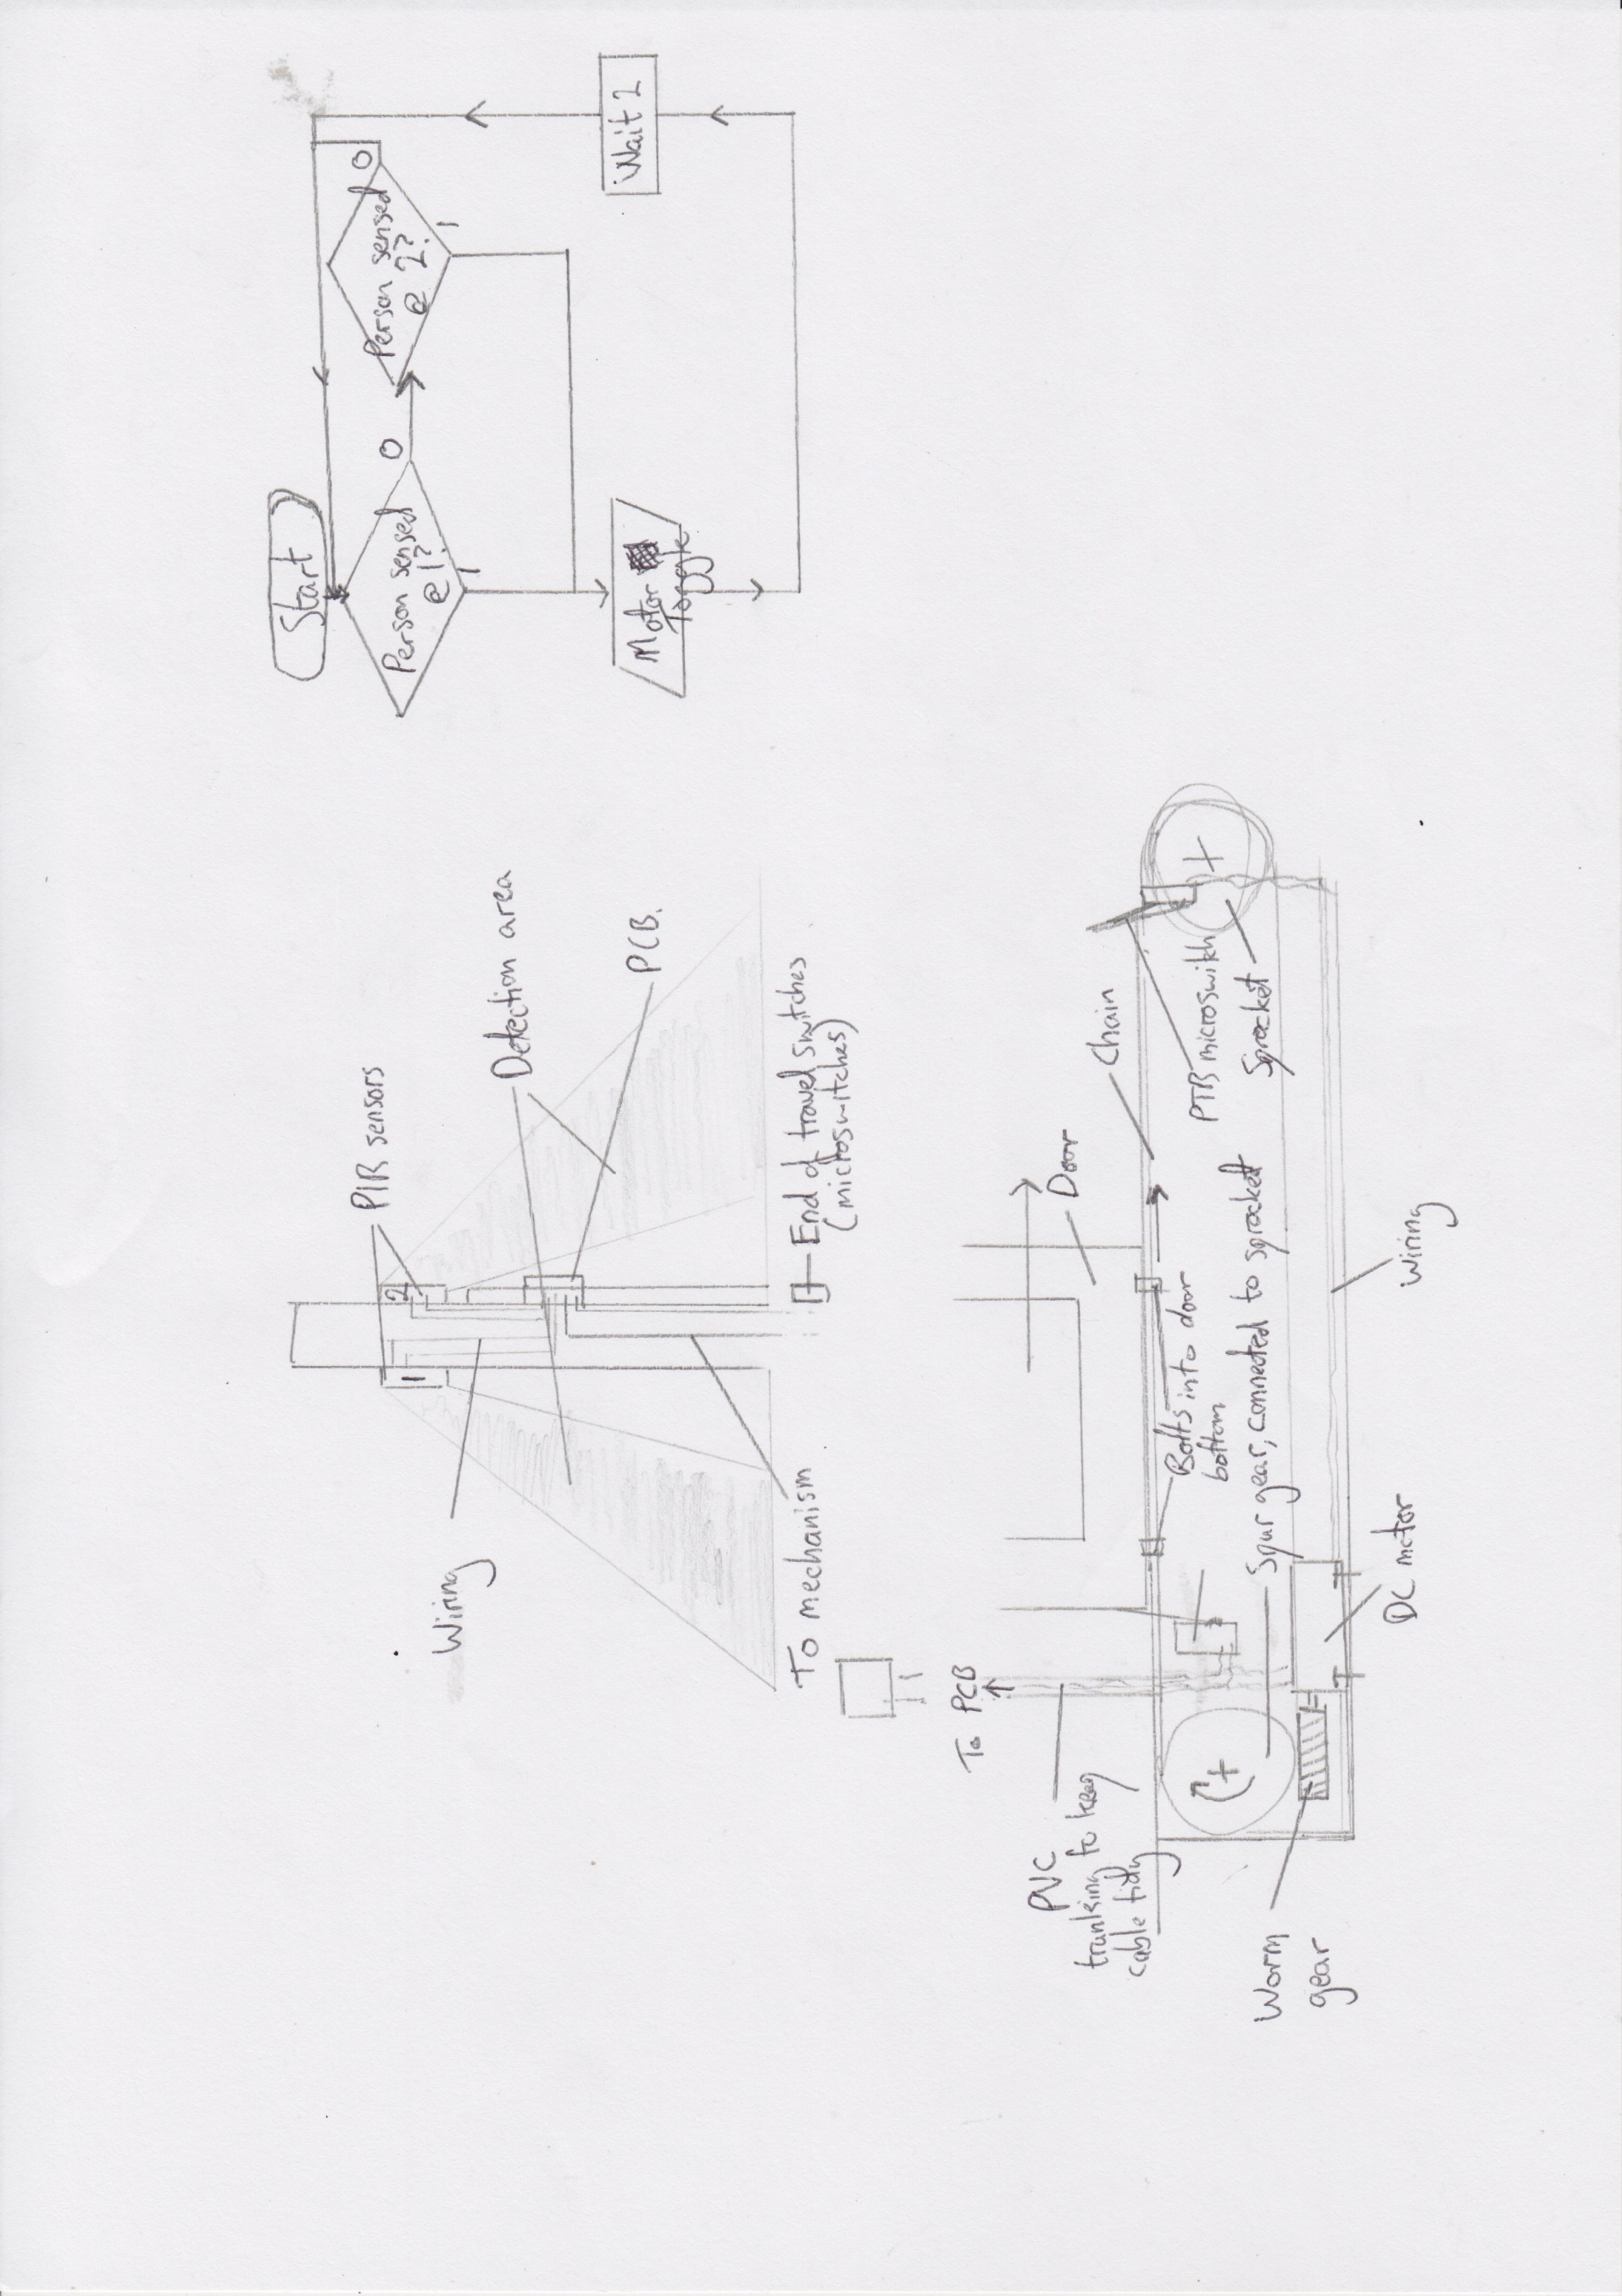7d. This design uses the same input sensors and program shown in part a. The PCB will be housed in an ABS box to protect it, and will have a removable cover held in place by M3 machine screws, and mounted to the wall with screws and wall plugs. To keep the cable tidy and prevent it from getting caught, I will run plastic trunking down the wall. In a refinement from my previous design, the door will be slid open and shut by the use of a sprocket and chain system. Using large washers placed over long bolts which are then passed through the links in the chain, then screwed into the door, the door can slide smoothly back and forth if a slot is cut into the lower guide for the door.

The gears and chain could be made from steel, and oiled to help reduce friction. The DC motor would be mounted to the floor with bolts going into wall plugs to secure them firmly. The sprocket/spur gear can be mounted on a steel shaft, secured to the wall. PTB microswitches could have a small aluminium bracket made, and then be secured with screws so that they can still stop the door when fully opened or closed.

*Note:* There are 12 marks for this question (in a paper worth 80; that’s 15%). I took no chances here, and neither should you! I said what every part I could think of was made from and how I’d hold it down. I put labels everywhere too, and tried to show where all the wiring should run from and to.

I regret not drawing close-ups of my chain/bolt/door idea, and if I were to do this again, I’d also show my spur gear (which transmits drive from the worm gear to the shaft that the sprocket is on) and how it connects to the sprocket (don’t forget, a sprocket is a gear that takes a chain). At the same time, the next part of the question covers this, hence not including it.

Essentially, what happens here is that you re-draw the answers to the previous question, but as one big diagram (I’ve had to break it up a bit for this exemplar), ensuring that all the individual parts of the system are shown. The idea of these questions is to show that you can connect all the sub-systems together to form a single, cohesive system that works to solve the problem set. Keep asking, “what else can I include?”

**Important:** I actually modified my design a bit by removing the rack and pinion. I’ve done this to show you an alternative way of solving the problem. You should avoid doing this. The examiner encourages candidates to refine their ideas (so you can remove redundant parts, and add little details to make it better), but unless absolutely necessary, stick with the concepts you introduced in the previous parts of the question.

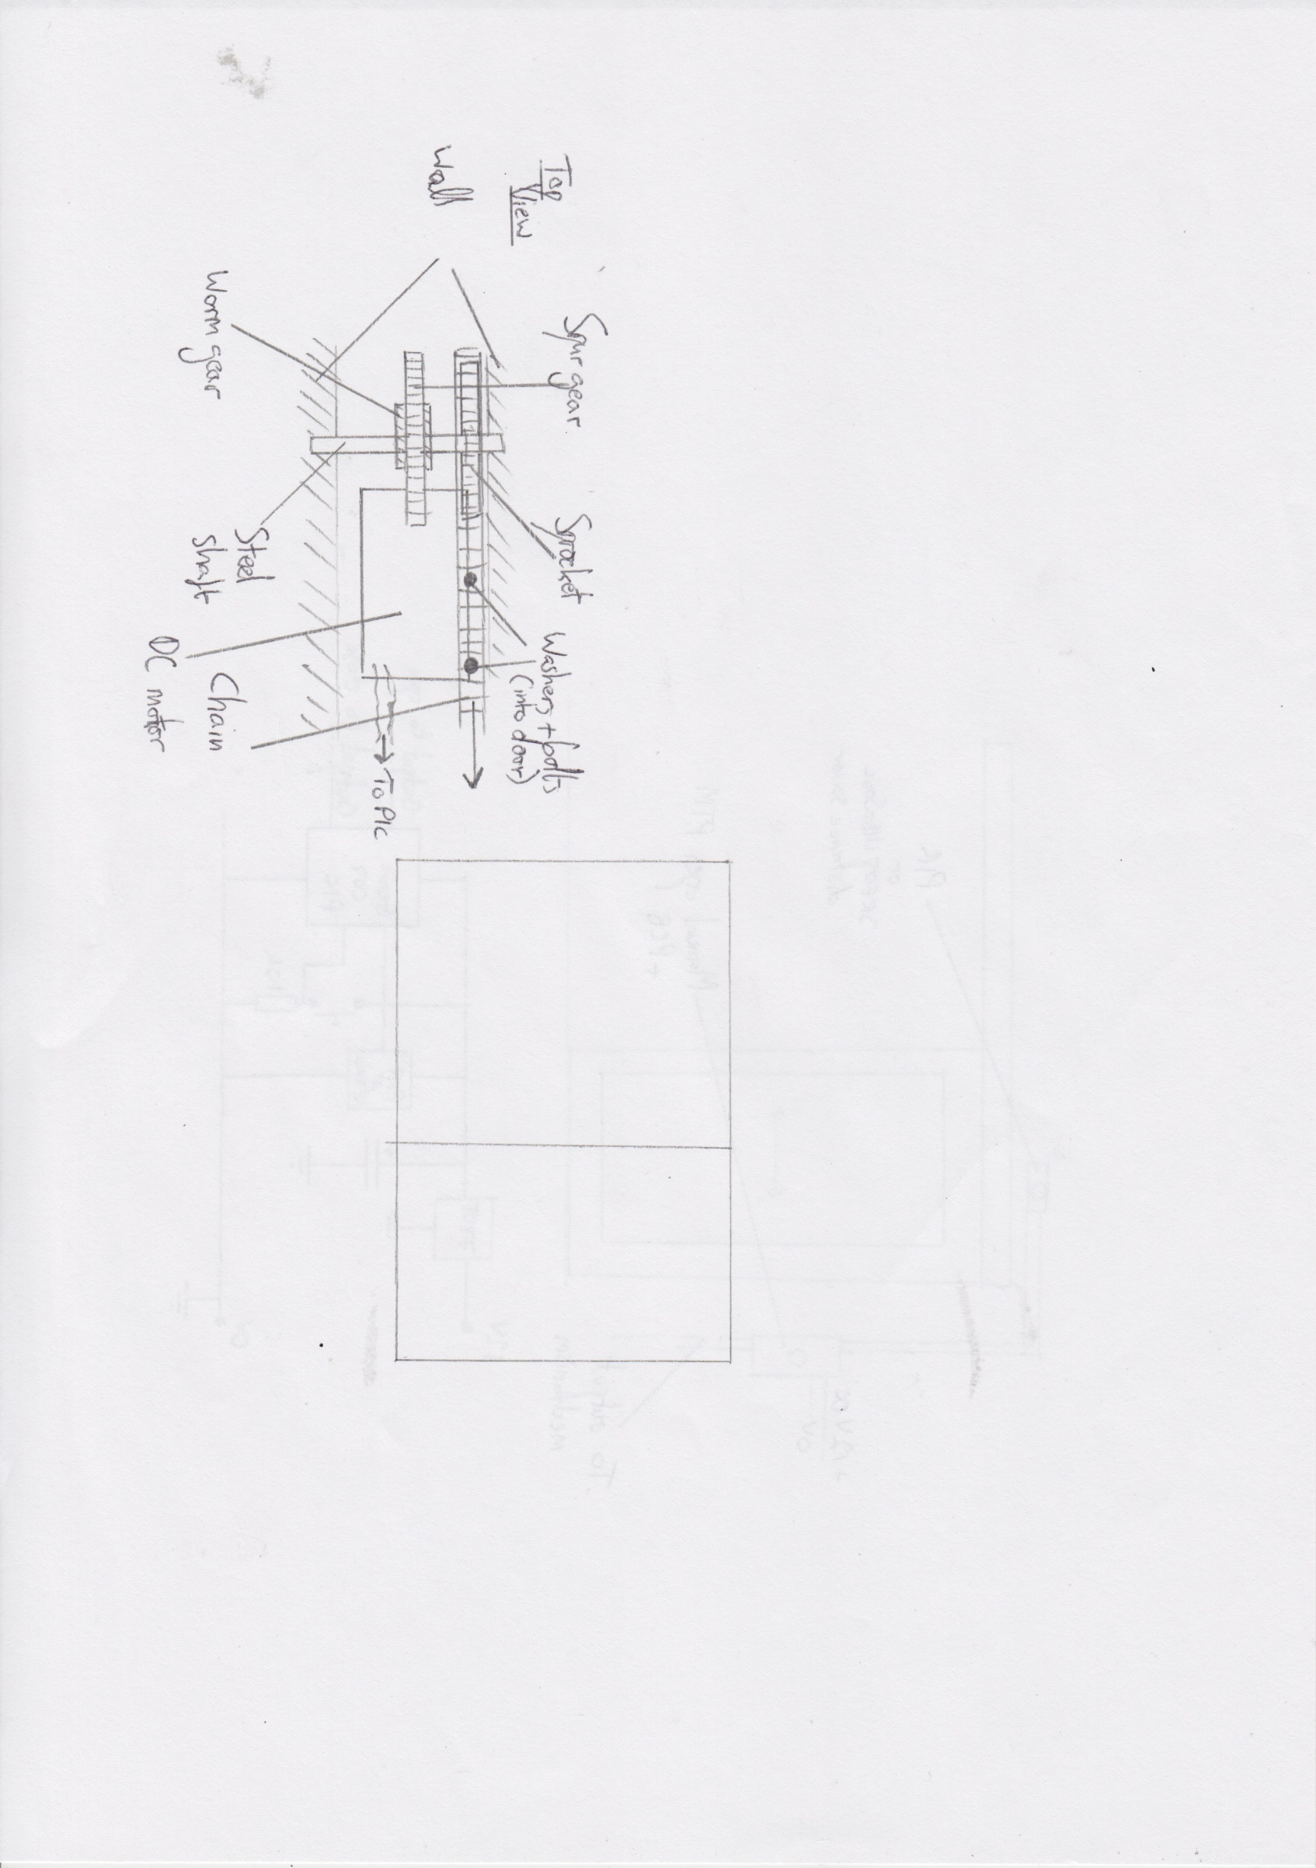7e. In my system, I would drill holes into the wall in order to mount the steel driveshafts that the gears are connected to. As the diagram shows, the DC motor is on the “floor” of the excavated area, and is fasted with wallplugs in the floor area, and could be either screwed or bolted down.

Mechanically, you can see the spur gear driven by the worm that resides underneath it. This turns the shaft, which turns the sprocket, causing the chain to drag the door to the right. As it is already suspended at its top, it should move smoothly to open and close, until it nudges the microswitches seen in the previous parts of the question.

As stated in previous parts of the question, the door is bonded to the chain by the use of thick bolts passed through the links of the chain, held in place with large washers on either side and then secured with nuts. As the nuts will never come into contact with the sprocket, this should work well.

*Note:* This question is asking for a little more detail on the practical aspects of how you’d actually make your idea work. I was tempted to show a side view as well, but decided against in the end, as I felt my second draft of the diagram was sufficiently detailed. Again, I made sure I explained how everything would be held in place, and was clear about how the mechanism was secured to the door itself to ensure I achieved all the marks.